**Appendix A**

**Outland Adventures**

**Full Case Study**

Team Name: The Outlanders



N/A. (n.d.). Hiking Clipart. Clipart Panda.

Retrieved July 9, 2022, from

<http://images.clipartpanda.com/hiking-clipart-hike.gif>

Team Members:

Chris Beatty - <https://github.com/AnotherByte/csd-310>.git

Brian Gossett - <https://github.com/BrianGossett/csd-310.git>

Larissa Passamani Lima - [https://github.com/passamani15/csd-310](https://github.com/passamani15/csd-310/tree/main/csd-310-1/).git

Christeen Safar - [https://github.com/ChristeenS/csd-310](https://github.com/ChristeenS/csd-310/tree/main/module_10).git

Michele Speidel - <https://github.com/jamdmmsfreese/csd-310>.git

Module 12.2 Assignment

Milestone #5

CSD310-330H_2225_DD

Database Development and Use

Date: July 21, 2022

Peer Review

On July 20, 2020, a peer review was conducted by our 330H Cohort students. Suggestions were also provided by Professor Sampson. We received some great comments overall but there are some areas of the presentation that require additional attached. Here are the issues and how we decided to address them:

| Comment or Suggestions | How Issues were addressed |
| --- | --- |
| Editing in general | Fixed |
| Are all the reports necessary to make the business decisions  (Professor Sampson)  It seemed like some of the reports were unnecessary and I found myself going back and forth between them all to see where the main questions of the study were being answered or if there was additional information on one report that pertained to the questions that were needing addressed even with the explanation slides for the reports. The extra reports, while a nice touch, could have been expanded on in the assumptions portion of the presentation.  (Tim Alvarado)  Since you have so much content, I would at least bold the answers to the questions given in the case study. It took a while for me to find them.  (Grace) | Two groups of reports were development  1. Key reports satisfy optimization requirements to help make business decisions  2.Functional reports satisfy the staff’s needs for reports based on their roles and responsibilities in the case study  The Key Reports slide specifically shows the key questions in the case study and addresses each of those questions. We did add an overview page to help the viewer with the flow of the presentation.  We also changed the name of “Other Key Reports” to “Functional Reports” to better differentiate between optimization and functionality. |
| Reports should have a date run  (Professor Sampson) | Dates were added to the reports in the presentation. |
| Most reports would benefit from being in a table form. It would be easier to quickly grasp the numbers.  (Professor Sampson) | Reports are in table form. |
| Seeing how trips to South America have declined to the point where there are none being booked, I started to think of ways to motivate people to go. I immediately thought of reasons why customers were not interested and how to change the perspective (if negative) to encourage an upward trend, instead of removing it altogether.  (Wendy) | Instead of indicating Africa and South America would be removed from the marketing plan, these 2 regions will now have a rebranding with the marketing team to spark travel interest. |
| I did notice the owners were assumed to be part of the payroll. I think the owners have been part of the administration and operation within the organization, which would make them a part of the payroll? Perhaps this was provided information as opposed to assumed?  (James) | Owners are part of the employee table. This  case study did not address payroll. No action was taken. |
| The astounding visual elements and the additional content made the report a little daunting to read upon preliminary inspection. However, after going through the whole report, I was relieved it was not as saturated as it first looked and was not at all cumbersome.  (James)  will say that as a whole, it is very busy and kind of hard to focus on the main draws of the presentation. There started to be too much information that I was getting overwhelmed reading it all. My only suggestion would be to edit and cut out anything that you do not need and mayne get rid of a few images that crowd the slides!  (Christopher)  The design could use a more consistent layout.  (Caleb) | Some of the pictures in the slides were toned down to make the presentation more consistent and easier to read.  We did add an overview page to help the viewer with the flow of the presentation. |
| I would purchase the “Mystery Box”.  (James) | Hurray! |
|  |  |
| This much text isn't needed in a presentation like this, especially when you have your appendix as well. Imagining a scenario where you're presenting this in a conference room, everyone would get the appendix as a handout, with the presentation up on a screen. In that case, the presentation should only highlight what's being said and what's in the handout.  (Caleb) | Additional information was added to the slide since we were not actually presenting our projects. |
| Slide 15 needs punctuation  (Grace) | Fixed |
| When you’re doing a presentation, it is better to be consistent throughout. On some slides you spelled out the numbers (four, forty-two, five, etc.) and in others you used the numerical. I’d pick one and stick with it.  (Grace) | Efforts were made to establish consistency. |
|  |  |

The Outlanders - Group Introduction

The Outlanders was formed on July 4, 2022, to handle Case Study for Outland Adventures. Our team is made of five eager students in the 330H Cohort Software Development Program at Bellevue University instructed by Profession Sampson and Professor Woods.

**Chris Beatty**

Has experience in database development. He also spends his time automating file storage and media on his home server.

**Brian Gossett**

Was a programmer in the military in web development. He is working on a degree here for his resume in the hopes of working for FAANG.

**Larissa Passamani Lima**

Is fairly new to database development. She has a degree in Criminal Justice, and experience in Supply Chain Operations. She is currently working as a Wave Technician for a Flow Center.

**Christeen Safar**

Has no experience in database development. She has two Bachelor's degrees in Child Development. Now, she works as a Personal Stylist at Macy’s, but she is planning to work in her new major.

**Michele Speidel**

Is an insurance professional and has experience in database development. She currently works in a remote position as a Business Analyst.

# Case Study Selected

Outland Adventure

Outland Adventures Case Study

Blythe Timmerson and Jim Ford, both outdoor enthusiasts, opened Outland Adventures as a sideline to their full time careers. They hoped to cater to other people who enjoyed hiking and camping in far off places. They thought that if they could arrange guided trips, provide the equipment needed, and develop the right advertising, then Outland Adventures might just succeed. When it became apparent that they had identified a much needed market, they both quit their current jobs and devoted their full time and energies into their joint venture.

When they started running Outland Adventures, they hired two guides; John ‘Mac’ MacNell, and D.B. ‘Duke’ Marland. These two would be in charge of organizing and planning the trips, including investigating airfares, visa requirements, and inoculations.. Blythe and Jim also hired Anita Gallegos to take over the marketing aspect of the organization. Dimitrios Stravopolous is responsible for ordering supplies for the trips as well as keeping the equipment inventory up to date. Customers may either rent or buy their equipment outright. Mei Wong has just been hired to develop an ecommerce site where potential customers can find out information about Outland Adventures, check on trip schedules, and purchase hiking and camping equipment.

While Blythe and Jim have been taking care of the administrative and office operations, they have recently started wondering if it was time to optimize the organization. Some of the questions to be answered are:

Do enough customers buy equipment to keep equipment sales?

So far, they have conducted treks in Africa, Asia, and Southern Europe. Is there anyone of those locations that has a downward trend in bookings?

They are a little concerned about the age of some of the inventory. Are there inventory items that are over five years old?

# Assumptions

-Owners are considered in the employee table

-Each destination has its own flat airline fee

-Only new equipment is purchased to sell or rent but the owners brought new equipment to the business which can be several years old

-Card number represents payment information customer would provide

-Every customer and employee on a trip is going on all excursions

-Items include equipment, supplies, and safety essentials

-Full inventory reports or available items reports were not create for this case study

-Camping is part of the excursion activities

-If customer_order table shows “is_rental” field as “0” or “false”, customer decided to buy equipment

-Each excursion will be documented per day (If excursion takes multiple days, it will be listed once per day)

-Each of the Guides will be required to have each of the items required for the trip

-If a trip requires an item, only one person will be required to check out the item

-The project does not provide interactive website reports for customers to check trip schedules or purchase equipment. There is an interactive report to show equipment over X years old.

-All trips are assumed to be paid for so there is no invoice or billing information provided in this report.

-The business has expanded since this case study was written to conduct trips in North America, Northern Europe, and South America

-Customer inoculation records were updated while evaluating this case study. Customers provided additional information since the tables were originally created.

A brief description of the case study

**Mission**

To provide adventurous guided trips for the hiking and camping enthusiasts

**Description of Case Study**

Outland Adventures was founded back in January 1, 2022 when Blythe Timmerson and Jim Ford decided to take a risk and dedicate their time and energy into the vision of what would become Outland Adventures. Their primary focus of the company was to share their passion with others.

The reason Outland Adventures has been thriving is because the organization focuses on providing the best quality experience with well informative guided tours, safety precautions, and adventure to far off places with great destinations that have been fully experienced priorly in order for the guides to offer the most well crafted excursions. Choosing the “Right Adventure” is the primary focus of the company to continue improving the experience provided to its customers.

**Mission of success**

* Focusing on customers
* Employing a great management team
* Keeping detailed financial records
* Continuing to innovate
* Pursuing long-term goals
* Adapting to new technology

Location of Store

The store is located at **2309 Iowa Center Rd, Neverland IA 09989**. The location allows customers to purchase the necessary equipment for their trip as well as providing information about their excursions to customers in person.

Adventure to Far Off Places

The idea of creating the “Outland Adventure” project was to find great destinations for curious travelers who are eager to discover new realms. These destinations are the world's best places to travel to; according to the experts. The locations where they have conducted treks are Africa, Asia, Northern Europe, Southern Europe, North America and many more. The founders of Outland Adventure were planning to arrange guided trips to the world's most wondrous places to create the best travel experience for their customers.

The “Right Adventures”

Outland Adventures was designed to offer great destination guided tours. The company has taken the time and efforts to get to know the places before adding them to their destination guides in order to provide unique experiences that cannot be found with any other guided organization. They have spent many months crafting excursions to different regions of the world. These regions have been purposely picked to be different from one another in order to provide a unique experience that cannot be repeated in another trip.

Behind the Organization

**Owners**

Blythe Timmerson and Jim Ford are the owners and CEOs of Outland Adventures.

They both share the passion for the outdoors, and continually devote their full time and energy into their joint venture.

**Tour Guides**

With 25 years of combined tour guiding experience, John ‘Mac’ MacNell, and D.B. ‘Duke’ Marland are the tour guides for every excursion.

They are also in charge of organizing and planning the trips, including investigating airfares, visa requirements, and inoculations.

**Support Team**

**Anita Gallegos** has 15 years of experience as a Marketing Analyst and is in charge of all of the marketing aspects of the organization.

**Mei Wong** has 10 years of experience in building excellent E-Commerce websites. She was just recently hired by Outland Aventures to build an E-Commerce site for the organization, to allow potential customers the ability to find out about trip schedules, types of excursions, and purchase or rent hiking and camping equipment in advance.

**Dimitrios Stravopolous** has 7 years of experience managing inventory. He was hired to be in charge of ordering supplies for the trips as well as keeping the equipment inventory up to date.

**Organization Chart**

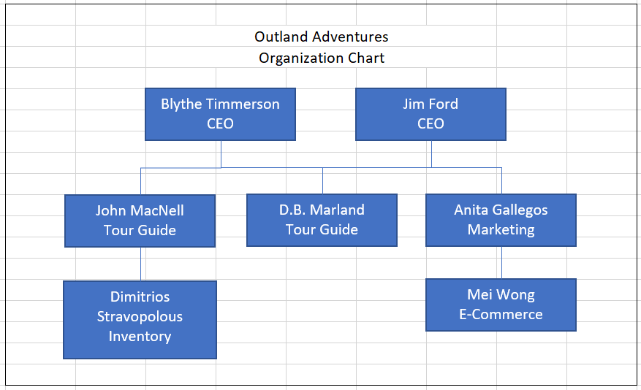

The Group ORD

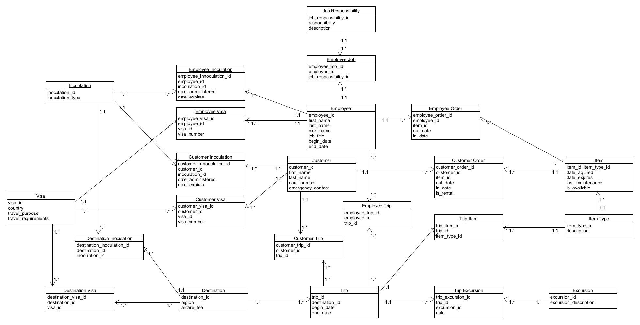

# List of Reports

1.Customer Buy

2.Customer Rent vs Buy

3.Region Total Trips

4.Region Total Customers

5.Trip Region Total Customer

6.Equipment Needed Per Trip

7.Customer Visa And Shot Records

8.Employee Visa And Shot Records

9.Trip Schedule

10-A.Item By Age

10-B.Item By Age Interactive

## **1.Customer Buy Report**

## **2.Customer Rent vs Buy Report**

### Purpose of Reports

These reports will help determine if enough customers buy enough equipment to keep equipment sales.

-The CEOs, Blythe and Jim, need these reports to analyze business optimization strategies regarding the sales of equipment.

### Report Description

These two reports show how the equipment sales are going. Report 1. displays the customer’s name, the item they purchased, and the date they purchased the item. Report 2. is a count of the items rented vs the items bought. Each time a customer orders an item, a record is created. This report compares the number of rental records against the number of purchase records. The result helps visualize the popularity of each option (rent vs buy).

#### 

#### 1.Customer Buy Report

SELECT C.first_name, C.last_name, IT.description, case when CO.is_rental = TRUE then 'Rent' else 'Buy' end AS 'Buy or Rent', CO.out_date

FROM item AS I

INNER JOIN item_type AS IT

ON I.item_type_id = IT.item_type_id

INNER JOIN customer_order AS CO

ON I.item_id = CO.item_id

INNER JOIN customer AS C

ON CO.customer_id = C.customer_id

WHERE CO.is_rental = false;

#### 

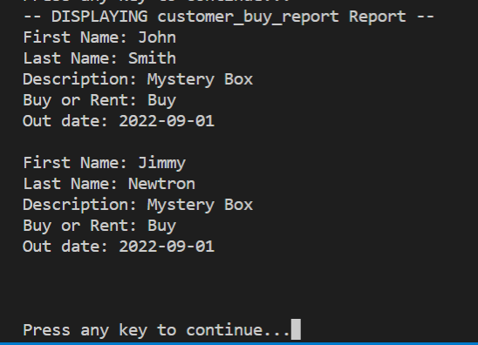

*Date Run: 07/17/2022*

#### 2.Customer Rent vs Buy Report Report

SELECT case when CO.is_rental = TRUE then 'Rent' else 'Buy' end AS 'RentVsBuy' , COUNT(*)

FROM item AS I

INNER JOIN item_type AS IT

ON I.item_type_id = IT.item_type_id

INNER JOIN customer_order AS CO

ON I.item_id = CO.item_id

INNER JOIN customer AS C

ON CO.customer_id = C.customer_id

GROUP BY CO.is_rental

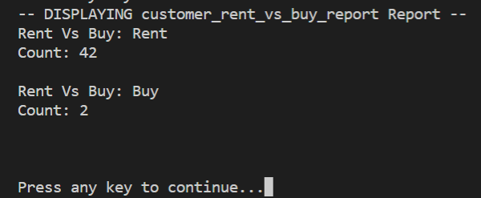

*Date Run: 07/17/2022*

## **3.Region Total Trips Report**

## **4.Region Total Customers**

## **5.Trip Region Total Customer**

### Purpose of Reports

These reports provide the total trips per region, the total customer count scheduled for each trip, and the customer count for each trip date to determine which destinations are popular vs unpopular.

-The CEOs, Blythe and Jim, need reports to show booking trends, specifically to determine if Africa, Asia, Southern Europe have downward trends in bookings

-Anita will need these reports to focus marketing efforts on certain regions based on business optimization goals

### Report Description

These three reports show how trip scheduling is going. Report 3. displays the number of trips planned per region. Report 4. Shows the number of customers scheduled for each trip region. Report 5. shows the date of each trip, which region is scheduled and how many customers are scheduled for each tip date. The results help determine how to optimize company resources, plan trips, and determine a concentrated marketing plan.

#### 3.Region Total Trips Report

List of destinations and how many trips to each destination (popular; not popular)

WHERE D.region='Africa' OR D.region='Asia' OR D.region='Southern Europe'

SELECT D.region AS 'Region', COUNT(T.trip_id) AS 'Total Trips'

FROM trip AS T

RIGHT JOIN destination AS D

ON T.destination_id = D.destination_id

GROUP by D.region

ORDER by D.region;

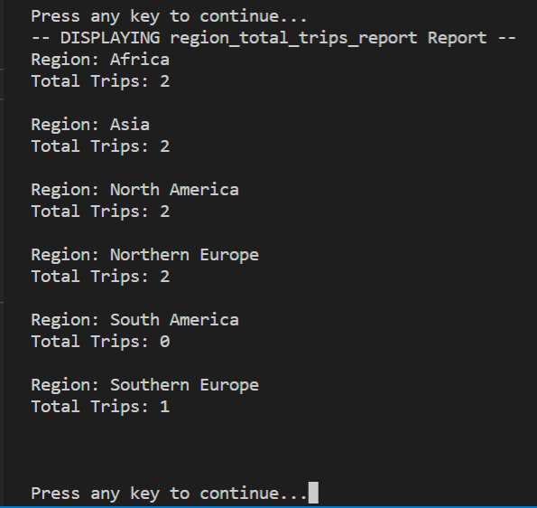

*Date Run: 07/17/2022*

#### 4.Region Total Customers Report

SELECT D.region AS 'Region', COUNT(CT.customer_trip_id) AS 'Total Customer Trips'

FROM customer_trip AS CT

RIGHT JOIN trip AS T

ON CT.trip_id = T.trip_id

RIGHT JOIN destination AS D

ON T.destination_id = D.destination_id

GROUP by D.region

ORDER by D.region;

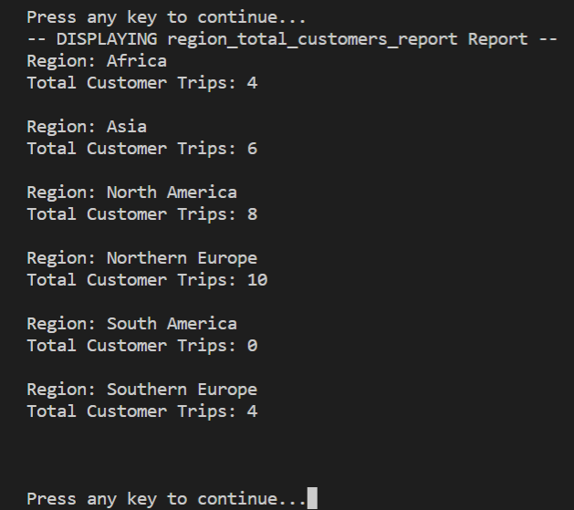

*Date Run: 07/17/2022*

#### 5.Trip Region Total Customer Report

SELECT T.trip_id AS 'Trip Number', D.region AS 'Region', T.begin_date AS 'Trip date', COUNT(CT.customer_trip_id) AS 'Total Customer Trips'

FROM customer_trip AS CT

RIGHT JOIN trip AS T

ON CT.trip_id = T.trip_id

RIGHT JOIN destination AS D

ON T.destination_id = D.destination_id

GROUP by T.trip_id

ORDER by T.begin_date;

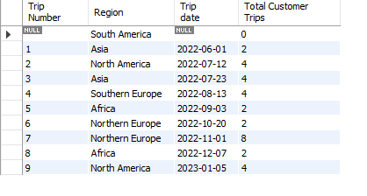

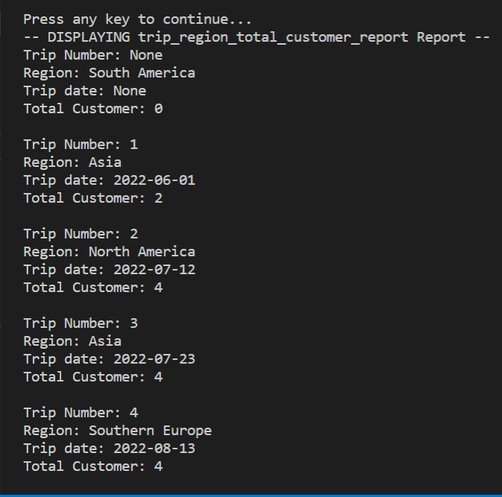

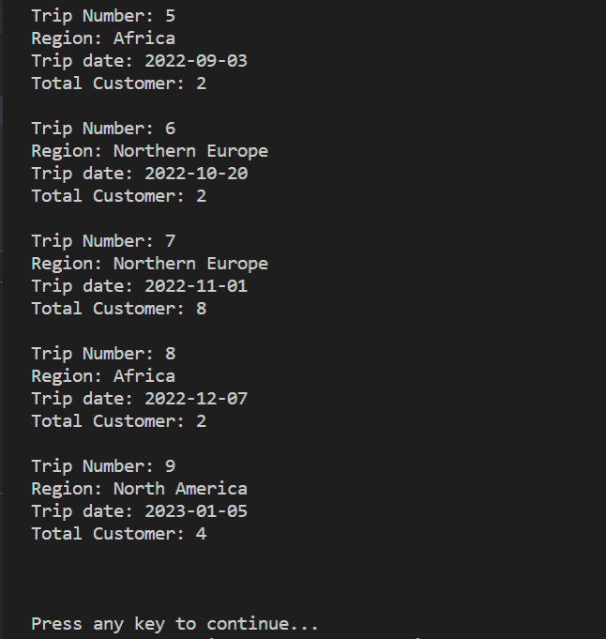

*Date Run: 07/17/2022*

## **6.Equipment Needed Per Trip Report**

### Purpose of Report

This report provides the equipment needed by region.

-Tour Guides and Customers will need to know what equipment is required per Trip so they can prepare to rent or sell.

-Dimitrios needs reports for trip inventory to identify what equipment is needed.

### Report Description

This report displays all of the required items for each of the trips. Each trip is listed for as many rows as items that are required on that trip. The trip_id and region name are displayed for each trip. The item description for each item needed is displayed rather than an item_type_id so it can be easily read. A “WHERE T.trip_id = ?” clause could be run on the view to limit the results to one trip.

#### 6.Equipment Needed Per Trip Report

--equipment needed per trip

SELECT T.trip_id, D.region, IT.description

FROM trip AS T

JOIN destination AS D

ON T.destination_id = D.destination_id

JOIN trip_item AS TI

ON T.trip_id = TI.trip_id

JOIN item_type AS IT

ON TI.item_type_id = IT.item_type_id

ORDER BY T.trip_id, IT.description;

#### 

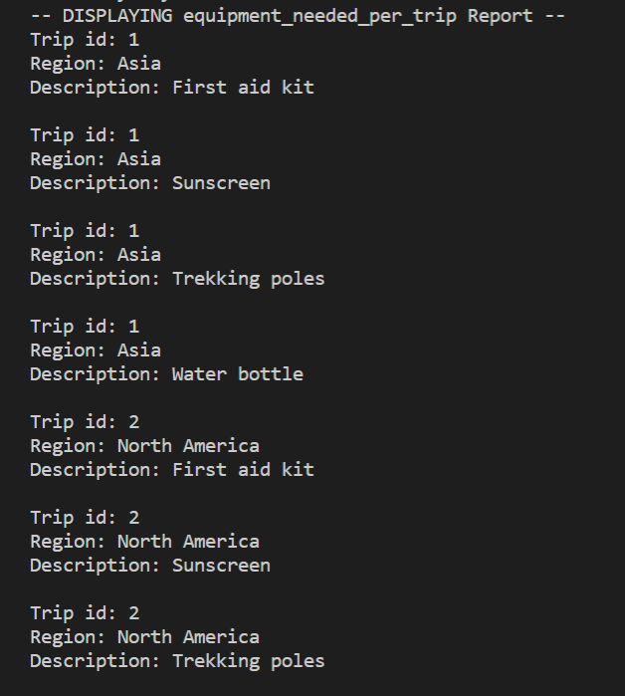

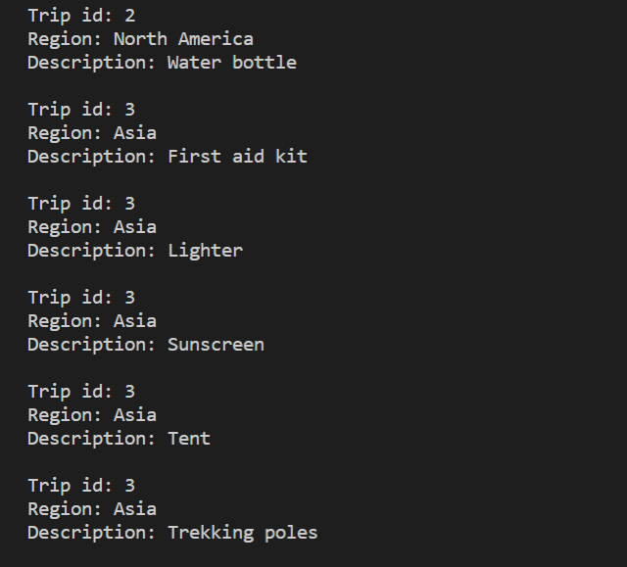

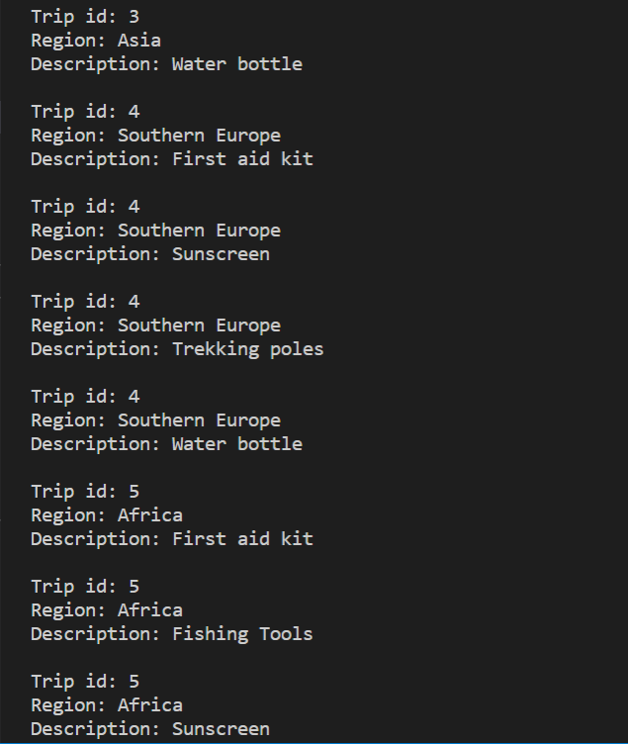

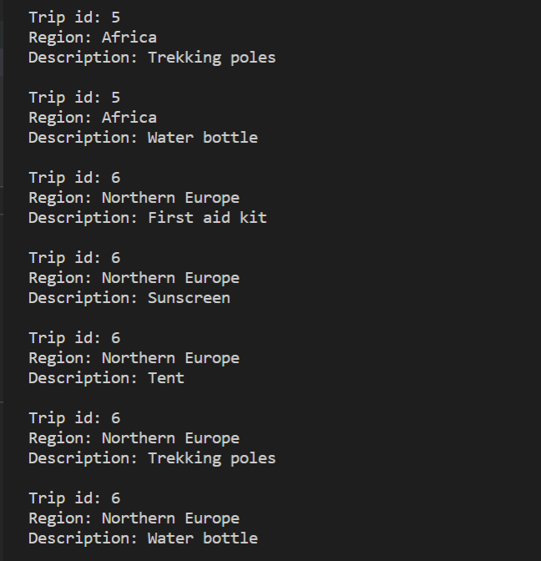

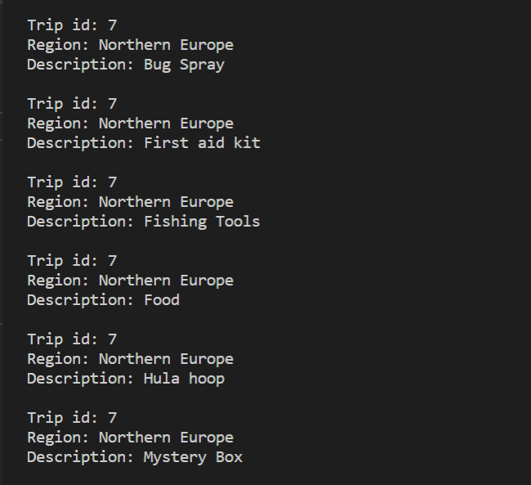

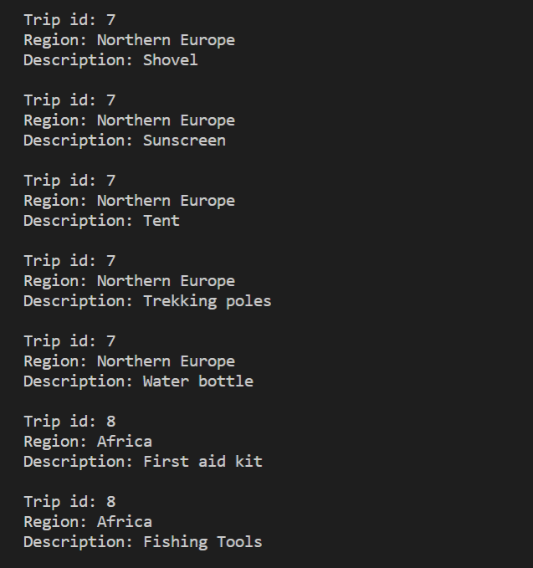

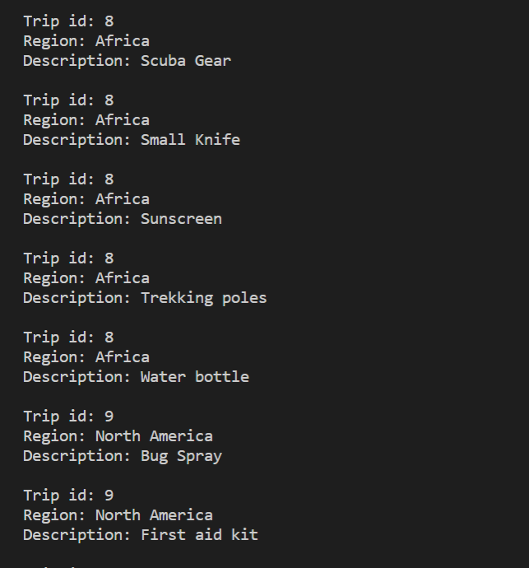

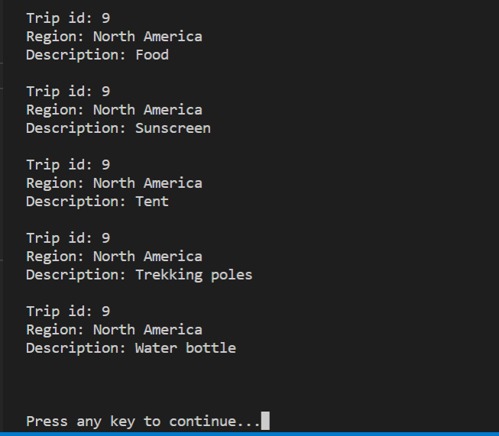

*Date Run: 07/17/2022*

## **7.Customer Visa And Shot Records**

## **8.Employee Visa And Shot Records**

### Purpose of Reports

These reports provide inoculation and visa details for each customer or employee for the regions and dates they plan to travel.

-Administration and Guides need these reports to determine inoculation and visa compliance

### Report Description

Report 7. provides customer details for each scheduled trip. It gives the guides a quick view of which customer(s) have satisfied their inoculation and visa requirements. If “NULL” is in the “has_inoculcation_type” or “has_visa_in_country”, the guides will be able to quickly gather that information and notify the customer(s) of the requirements.

Report 8. provides employee details for each scheduled trip. It gives the Administration a quick view of which employee(s) have satisfied their inoculation and visa requirements. If “NULL” is in the “has_inoculcation_type” or “has_visa_in_country”, the Administration will be able to quickly gather that information and notify the appropriate employee(s) of the requirements.

#### 7.Customer Visa and Shot Records Report

Guide(s) & Customers going on which trips inoculation and visa requirements

-confirm visa

-confirm shots

SELECT abc.customer_trip_id, abc.trip_id, a.begin_date, a.end_date, b.first_name, b.last_name, c.region, e.inoculation_type AS required_inoculation_type, report_data.has_inoculation_type, report_data.date_expires, visa_report.required_country_visa, visa_report.has_visa_in_contry, visa_report.visa_number

FROM customer_trip AS abc

INNER JOIN trip AS a

ON abc.trip_id = a.trip_id

INNER JOIN customer AS b

ON abc.customer_id = b.customer_id

INNER JOIN destination AS c

ON a.destination_id = c.destination_id

INNER JOIN destination_inoculation AS d

ON c.destination_id = d.destination_id

INNER JOIN inoculation AS e

ON d.inoculation_id = e.inoculation_id

LEFT JOIN (

SELECT a.customer_trip_id, g.first_name, c.inoculation_type AS has_inoculation_type, b.date_expires, b.inoculation_id, b.customer_inoculation_id

FROM customer AS g

INNER JOIN customer_inoculation AS b

ON g.customer_id = b.customer_id

INNER JOIN customer_trip AS a

ON g.customer_id = a.customer_id

INNER JOIN inoculation AS c

ON b.inoculation_id = c.inoculation_id

) report_data ON abc.customer_trip_id = report_data.customer_trip_id AND e.inoculation_type = report_data.has_inoculation_type

INNER JOIN (

SELECT abc.customer_trip_id, abc.trip_id, a.begin_date, a.end_date, b.first_name, b.last_name, c.region, e.country As required_country_visa, report_data.has_visa_in_contry, report_data.visa_number

FROM customer_trip AS abc

INNER JOIN trip AS a

ON abc.trip_id = a.trip_id

INNER JOIN customer AS b

ON abc.customer_id = b.customer_id

INNER JOIN destination AS c

ON a.destination_id = c.destination_id

INNER JOIN destination_visa AS d

ON c.destination_id = d.destination_id

INNER JOIN visa AS E

ON d.visa_id = e.visa_id

LEFT JOIN (

SELECT a.customer_trip_id, g.first_name, c.country AS has_visa_in_contry, b.visa_number, b.visa_id

FROM customer AS g

INNER JOIN customer_visa AS b

ON g.customer_id = b.customer_id

INNER JOIN customer_trip AS a

ON g.customer_id = a.customer_id

INNER JOIN visa AS c

ON b.visa_id = c.visa_id

) report_data ON abc.customer_trip_id = report_data.customer_trip_id AND e.country = report_data.has_visa_in_contry

) visa_report ON abc.customer_trip_id = visa_report.customer_trip_id;

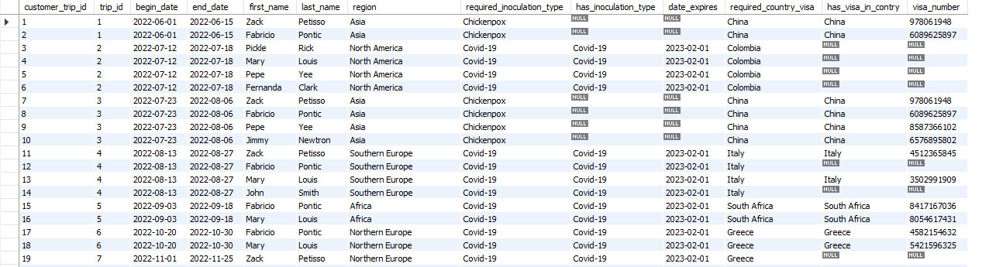

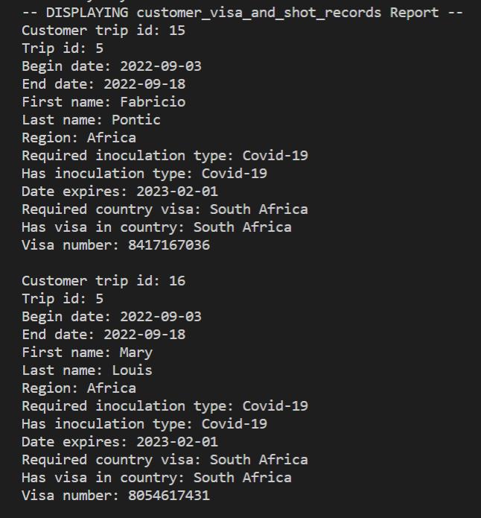

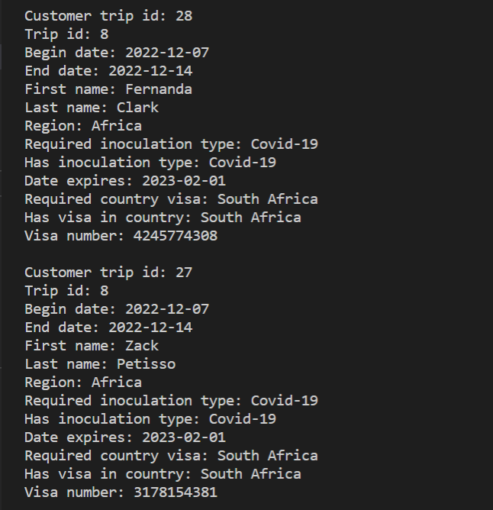

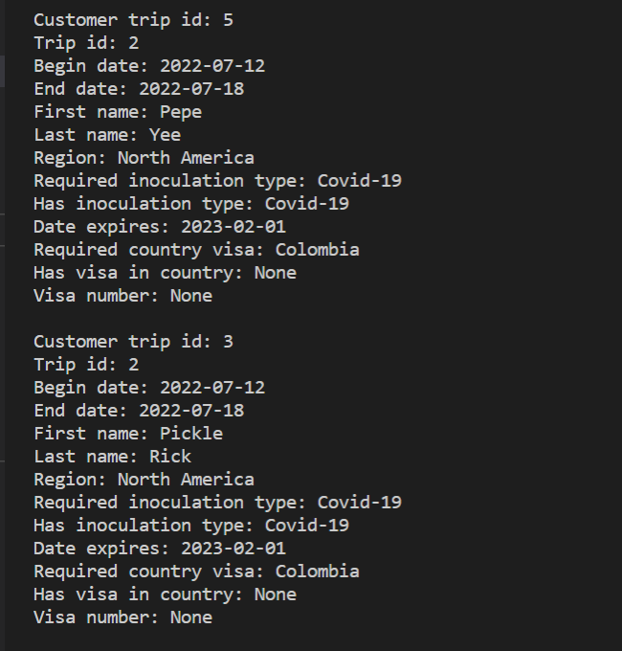

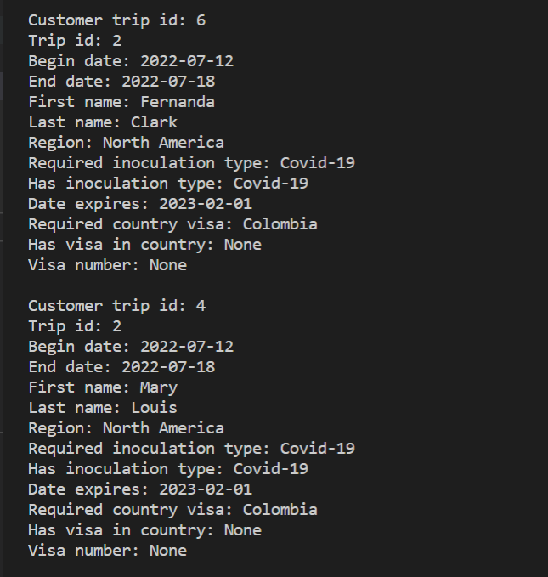

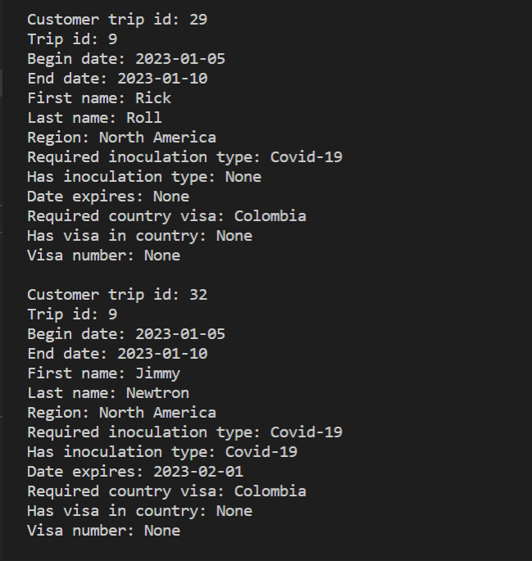

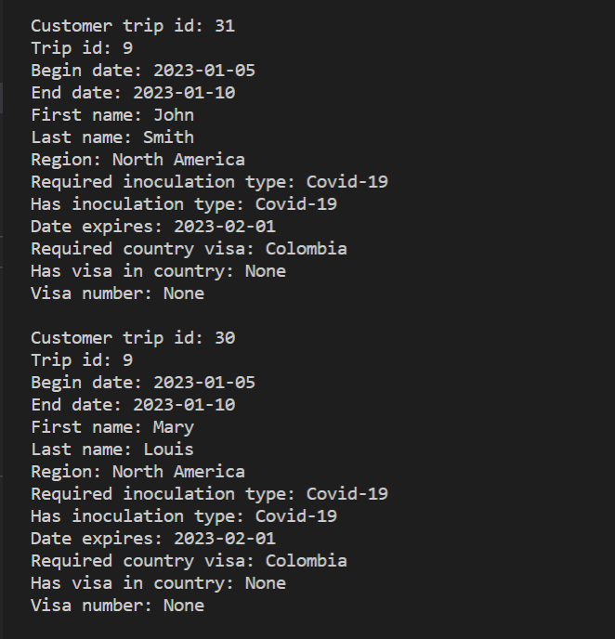

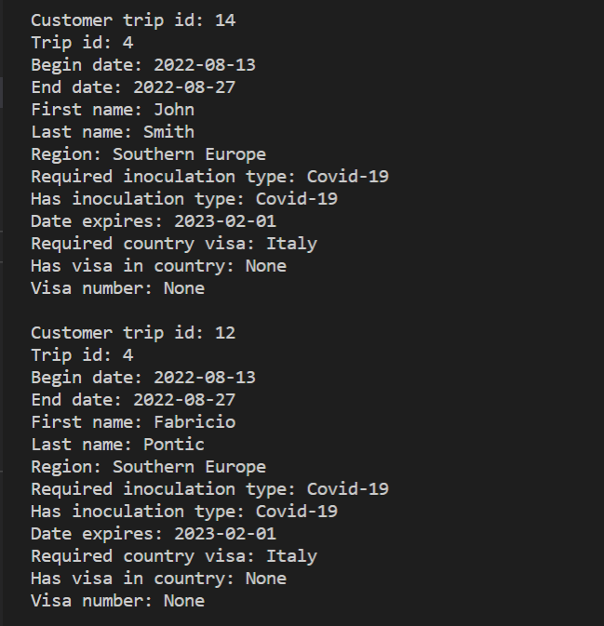

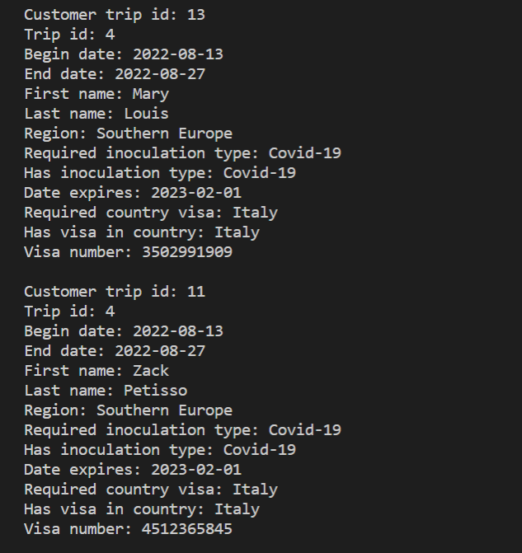

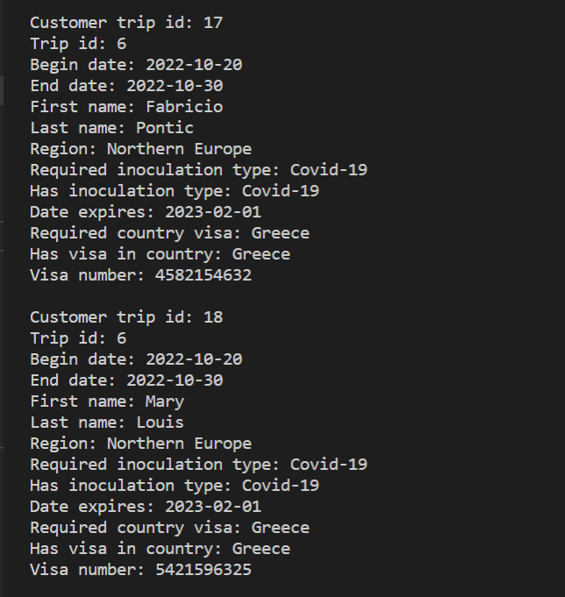

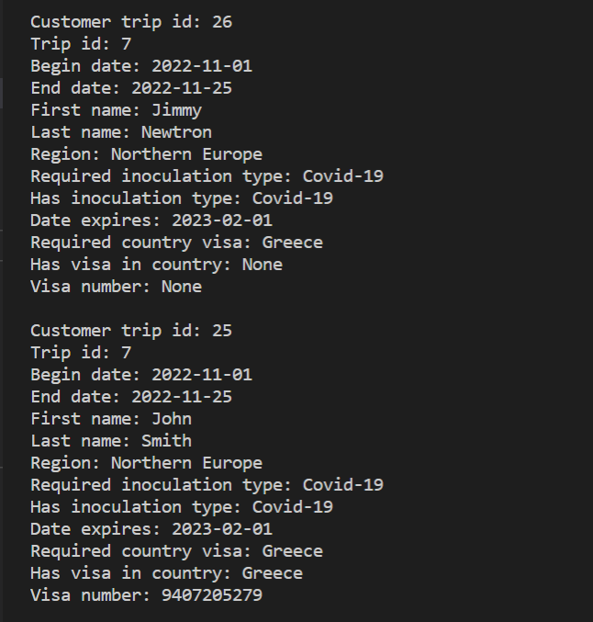

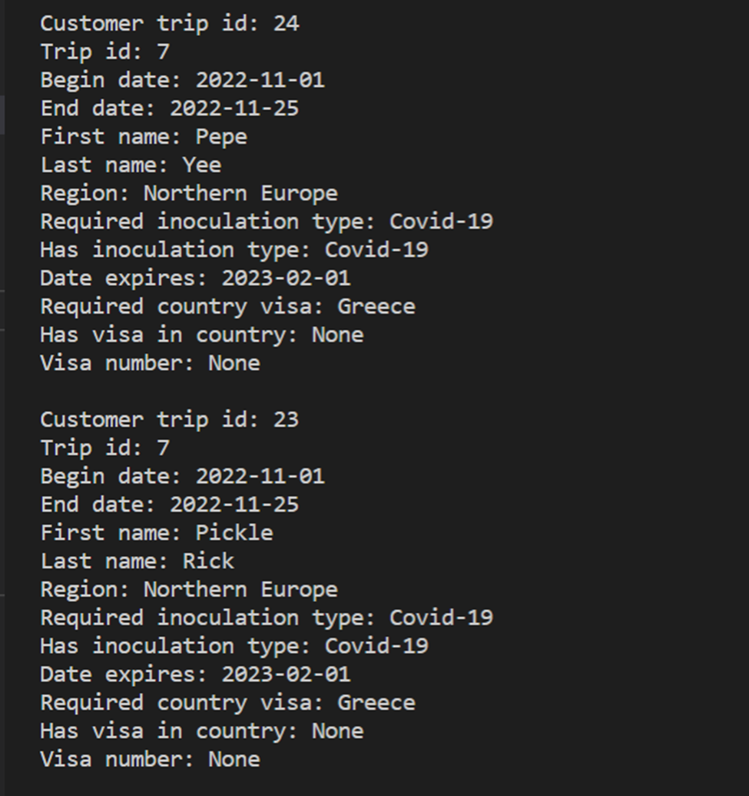

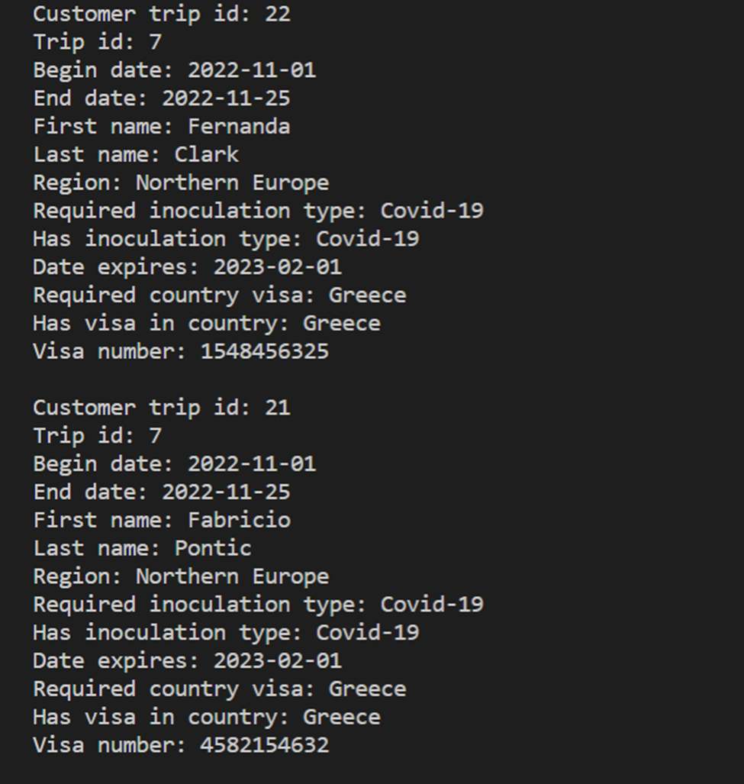

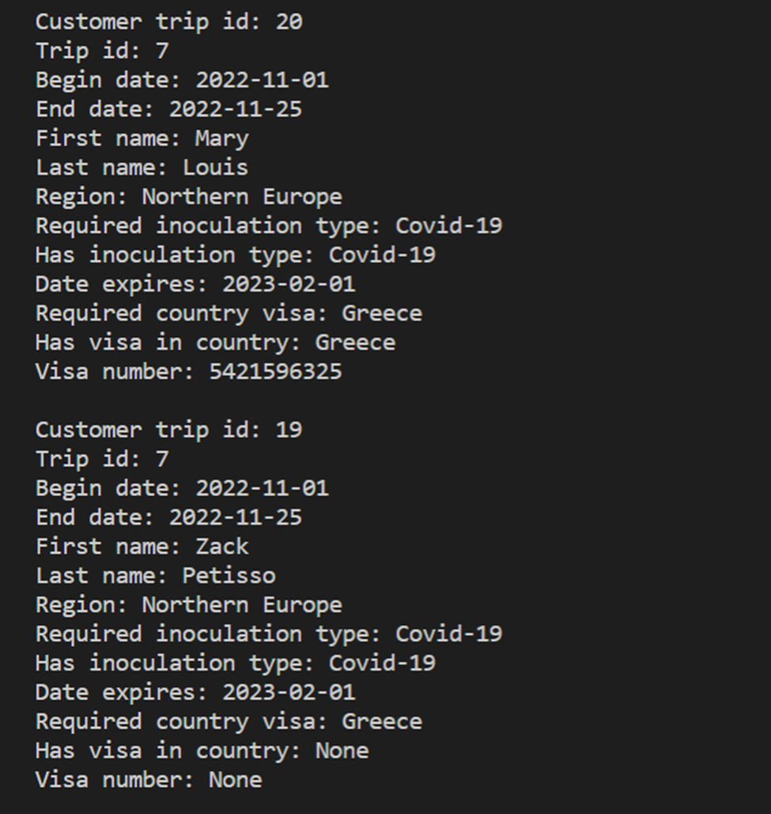

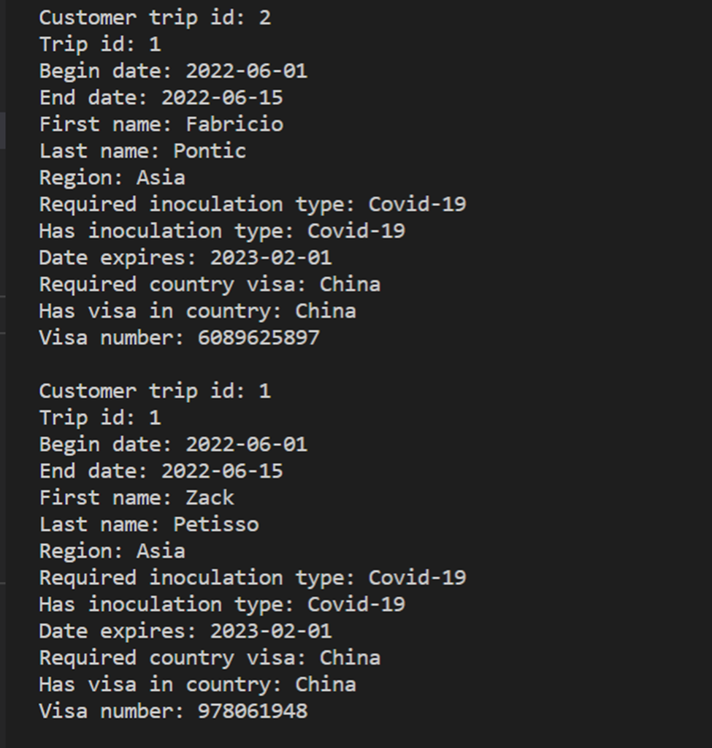

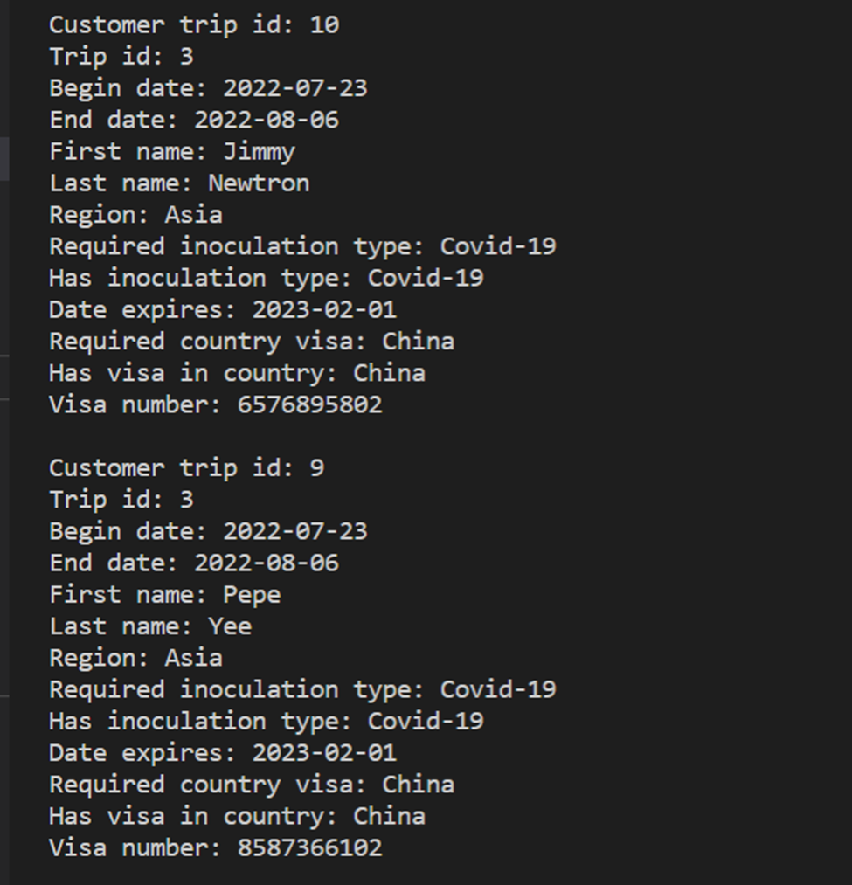

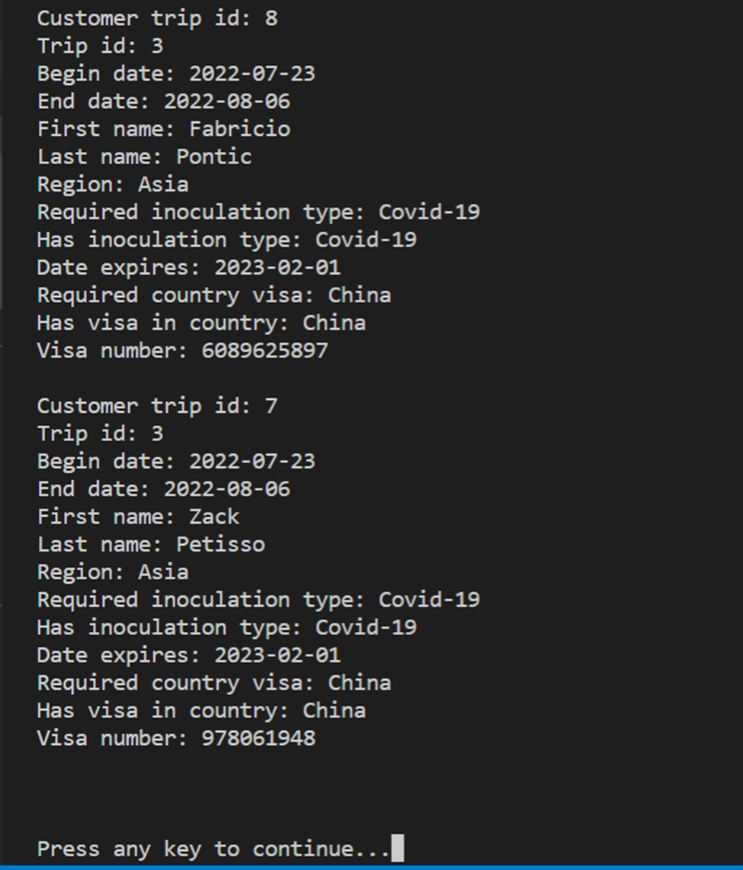

*Date Run: 07/17/2022*

#### 8.Employee Visa And Shot Records Report

CREATE VIEW employee_visa_and_shot_records AS

SELECT abc.employee_trip_id, abc.trip_id, a.begin_date, a.end_date, b.first_name, b.last_name, c.region, e.inoculation_type AS required_inoculation_type, report_data.has_inoculation_type, report_data.date_expires, visa_report.required_country_visa, visa_report.has_visa_in_contry, visa_report.visa_number

FROM employee_trip AS abc

INNER JOIN trip AS a

ON abc.trip_id = a.trip_id

INNER JOIN employee AS b

ON abc.employee_id = b.employee_id

INNER JOIN destination AS c

ON a.destination_id = c.destination_id

INNER JOIN destination_inoculation AS d

ON c.destination_id = d.destination_id

INNER JOIN inoculation AS e

ON d.inoculation_id = e.inoculation_id

LEFT JOIN (

SELECT a.employee_trip_id, g.first_name, c.inoculation_type AS has_inoculation_type, b.date_expires, b.inoculation_id, b.employee_inoculation_id

FROM employee AS g

INNER JOIN employee_inoculation AS b

ON g.employee_id = b.employee_id

INNER JOIN employee_trip AS a

ON g.employee_id = a.employee_id

INNER JOIN inoculation AS c

ON b.inoculation_id = c.inoculation_id

) report_data ON abc.employee_trip_id = report_data.employee_trip_id AND e.inoculation_type = report_data.has_inoculation_type

INNER JOIN (

SELECT abc.employee_trip_id, abc.trip_id, a.begin_date, a.end_date, b.first_name, b.last_name, c.region, e.country As required_country_visa, report_data.has_visa_in_contry, report_data.visa_number

FROM employee_trip AS abc

INNER JOIN trip AS a

ON abc.trip_id = a.trip_id

INNER JOIN employee AS b

ON abc.employee_id = b.employee_id

INNER JOIN destination AS c

ON a.destination_id = c.destination_id

INNER JOIN destination_visa AS d

ON c.destination_id = d.destination_id

INNER JOIN visa AS E

ON d.visa_id = e.visa_id

LEFT JOIN (

SELECT a.employee_trip_id, g.first_name, c.country AS has_visa_in_contry, b.visa_number, b.visa_id

FROM employee AS g

INNER JOIN employee_visa AS b

ON g.employee_id = b.employee_id

INNER JOIN employee_trip AS a

ON g.employee_id = a.employee_id

INNER JOIN visa AS c

ON b.visa_id = c.visa_id

) report_data ON abc.employee_trip_id = report_data.employee_trip_id AND e.country = report_data.has_visa_in_contry

) visa_report ON abc.employee_trip_id = visa_report.employee_trip_id;

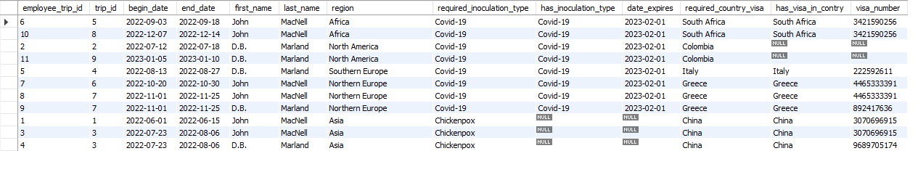

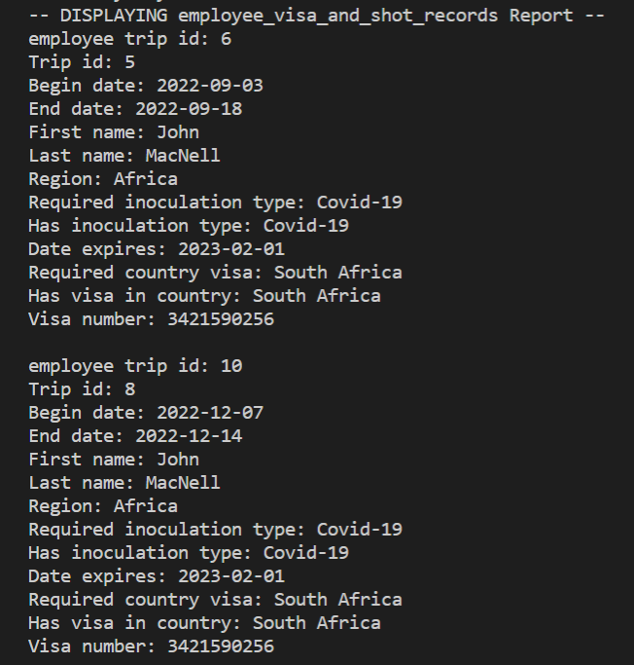

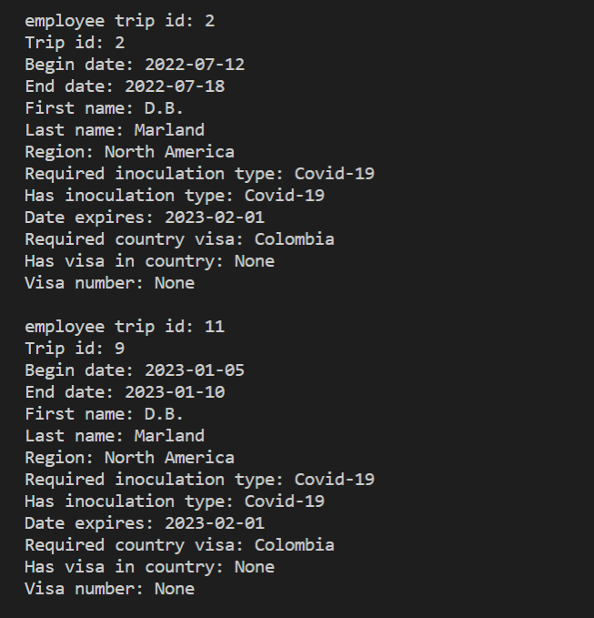

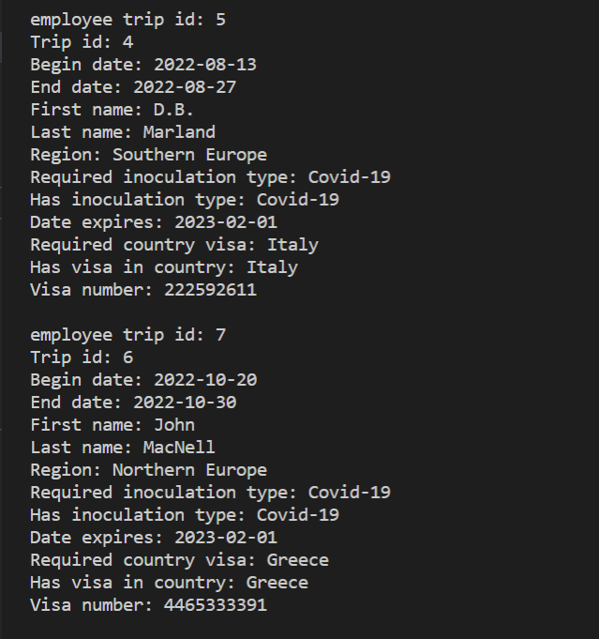

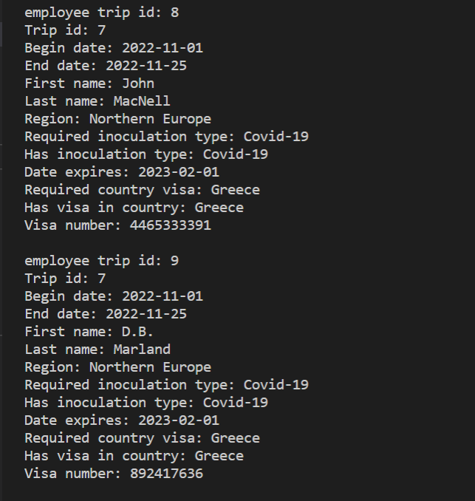

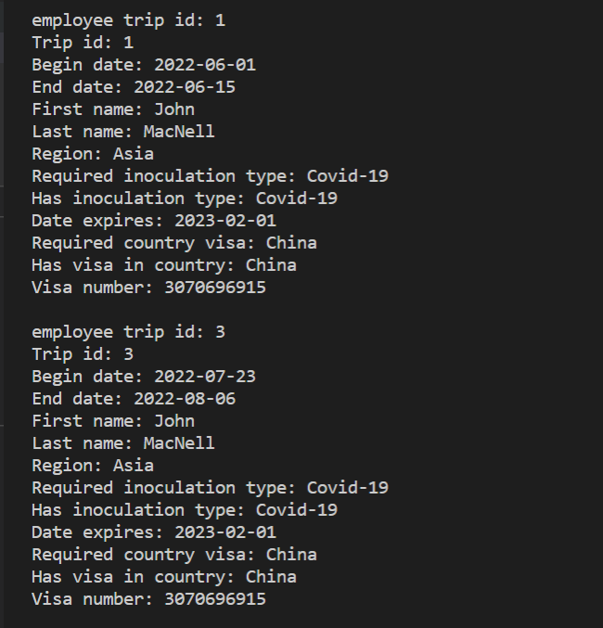

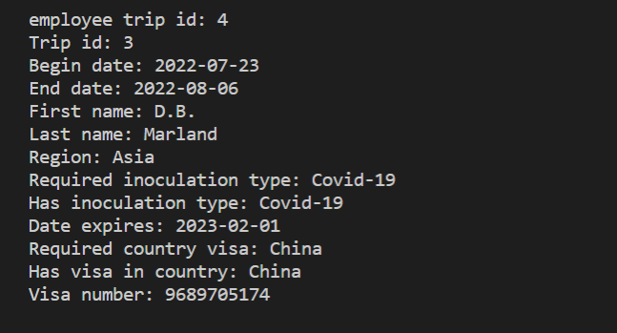

*Date Run: 07/17/2022*

## **9.Trip Schedule Report**

### Purpose of Report

-Mei Wong needs a report so potential customers can check on trip schedules

### Report Description

This report displays the beginning and ending dates for each trip along with each excursion and its date that is a part of that trip. Each trip is listed for as many times as the amount of excursions on that trip. The trip_id and region name are displayed for each trip. Each excursion has the event description and the date it takes place on. A “WHERE T.trip_id = ?” clause could be run on the view to limit the results to one trip, which would make the result useful as a trip itinerary.

#### 9.Trip Schedule Report

SELECT T.trip_id, D.region,

DATE_FORMAT(T.begin_date,'%m/%d/%Y') AS 'Begin Date',

DATE_FORMAT(T.end_date,'%m/%d/%Y') AS 'End Date',

DATE_FORMAT(TE.date,'%m/%d/%Y') AS 'Excursion Date',

E.excursion_description

FROM trip AS T

JOIN destination AS D

ON T.destination_id = D.destination_id

JOIN trip_excursion AS TE

ON TE.trip_id = T.trip_id

JOIN excursion AS E

ON E.excursion_id = TE.excursion_id

ORDER BY T.begin_date, TE.date;

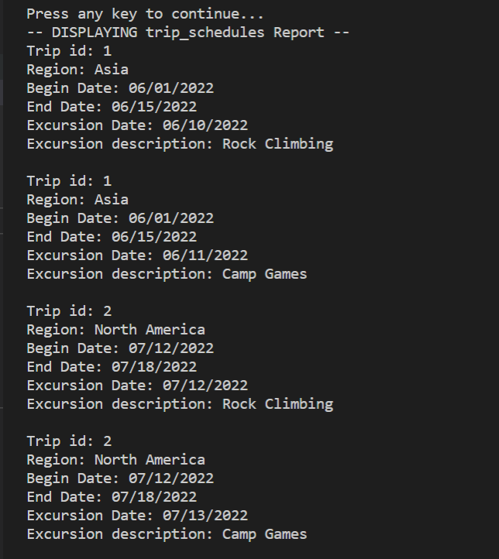

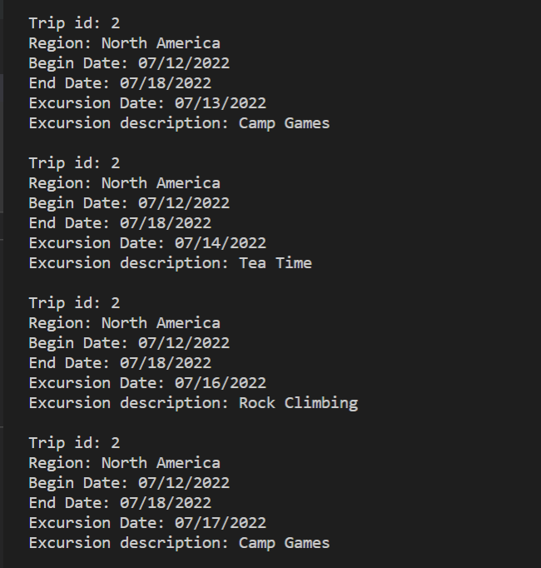

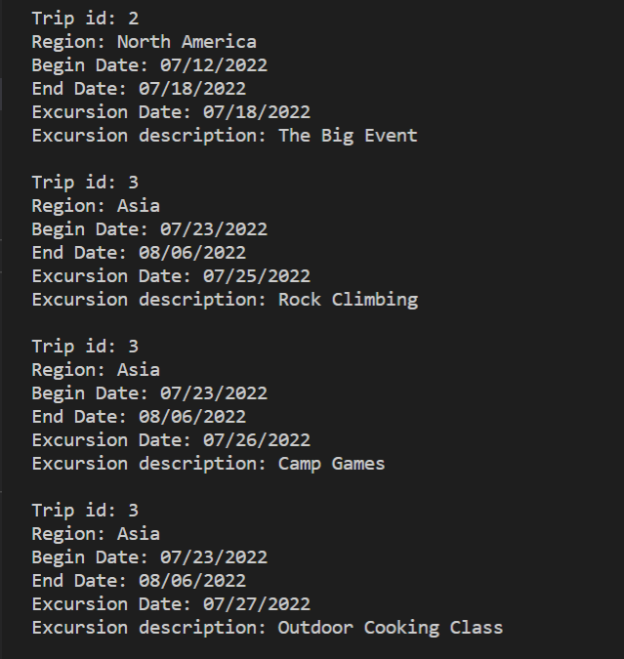

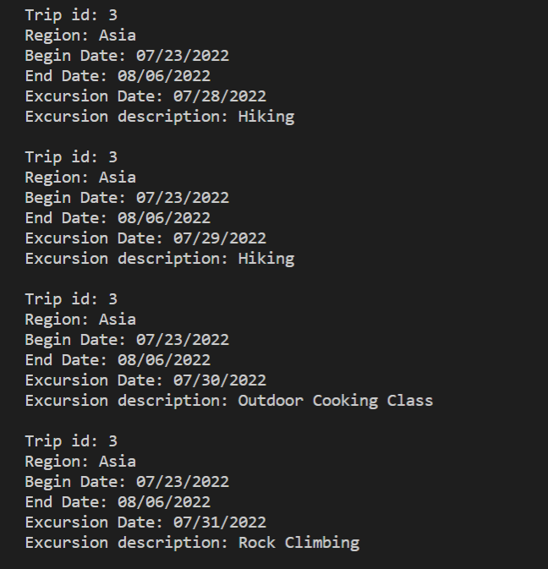

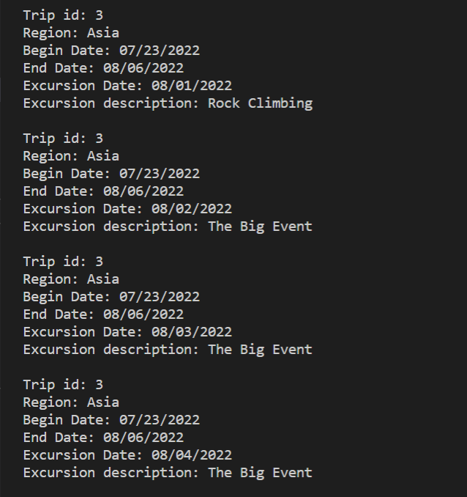

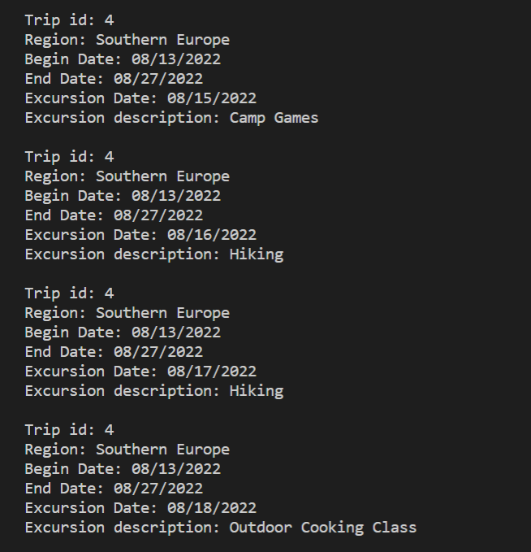

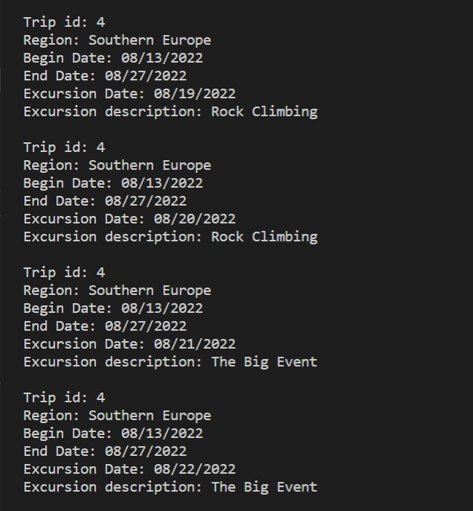

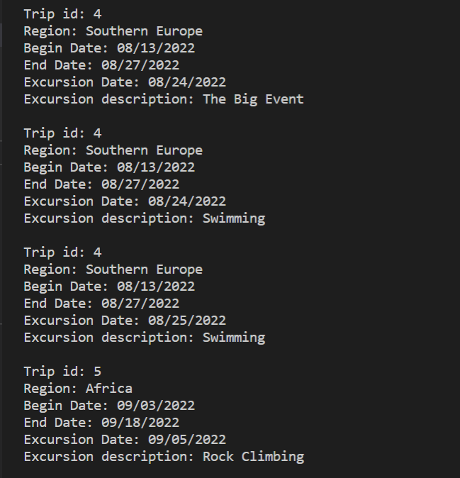

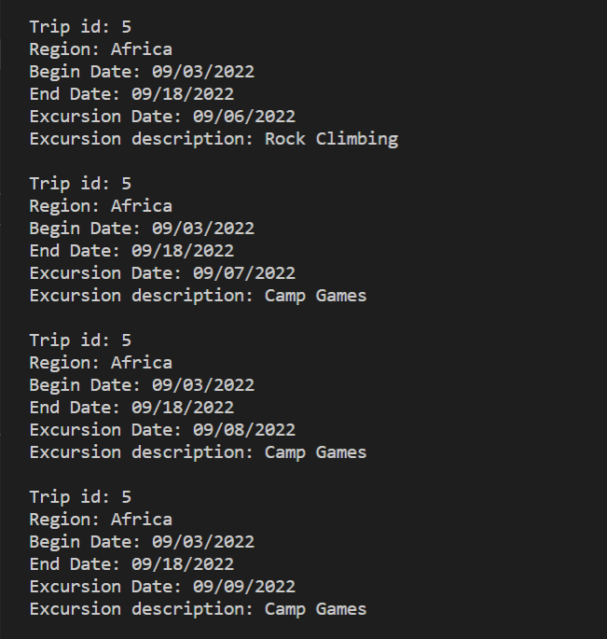

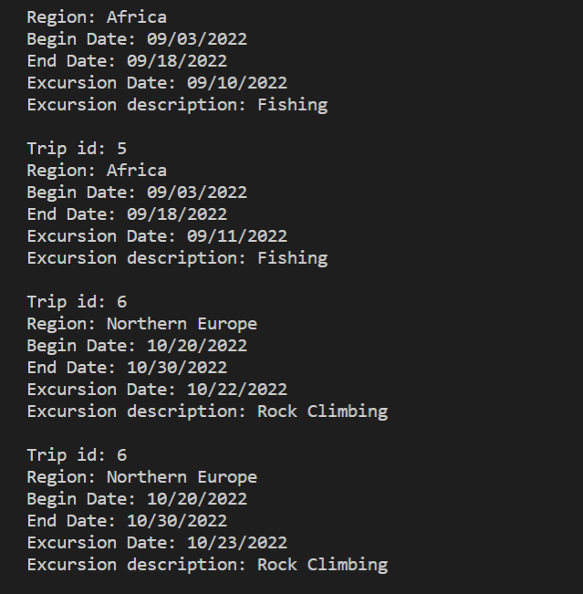

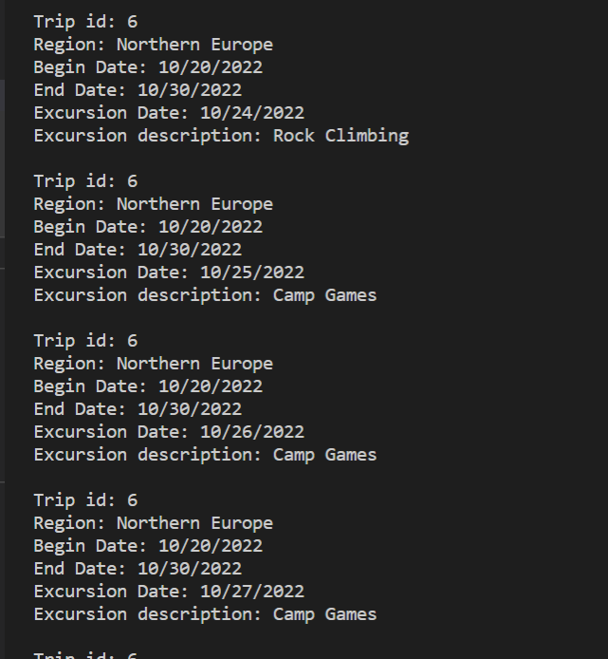

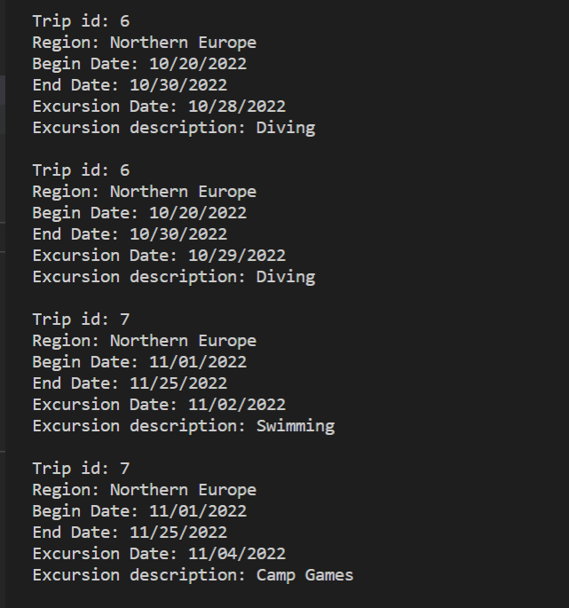

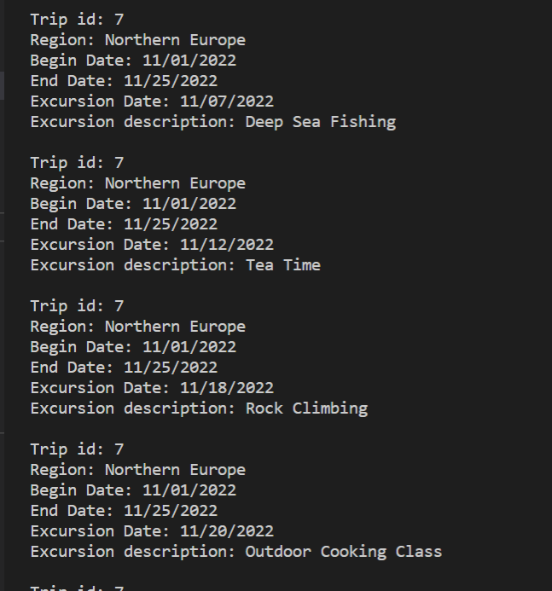

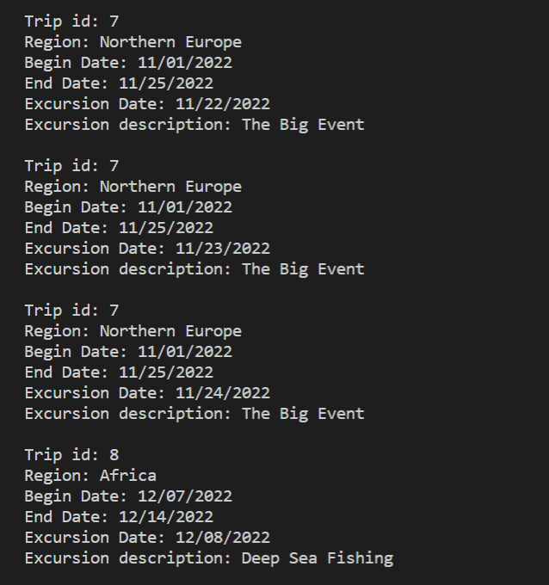

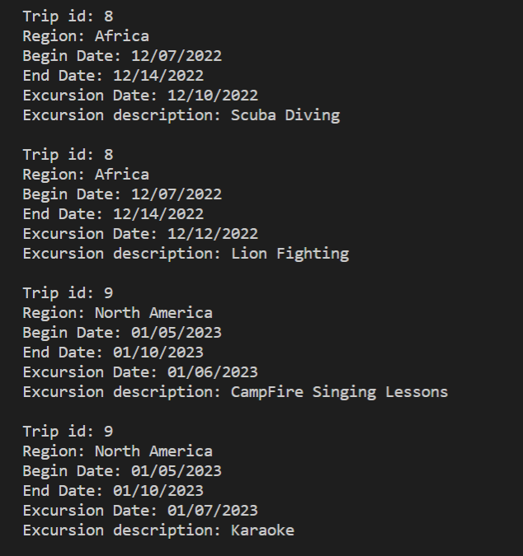

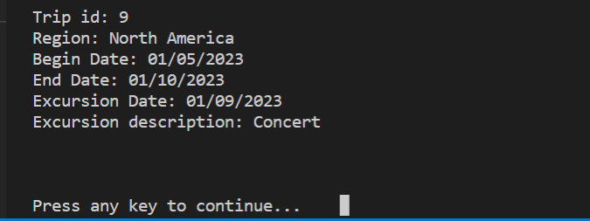

*Date Run: 07/17/2022*

## **10-A.Item By Age Report**

## **10-B.Item By Age Report**

### Purpose of Reports

These reports provide inventory details.

The interactive report is used to identify the equipment with an age greater than the age entered.

-Dimitrios needs reports for equipment inventory and maintenance.

#### 10-A.Item By Age Report

--all items

SELECT I.item_id, IT.description,

DATEDIFF(CURDATE(), I.date_aquired) AS 'Age in Days',

DATEDIFF(CURDATE(), I.date_aquired)/365.25 AS 'Age in Years',

DATE_FORMAT(I.date_aquired,'%m/%d/%Y') AS 'Date Acquired'

FROM item AS I

JOIN item_type AS IT

ON i.item_type_id = IT.item_type_id

ORDER BY I.date_aquired;

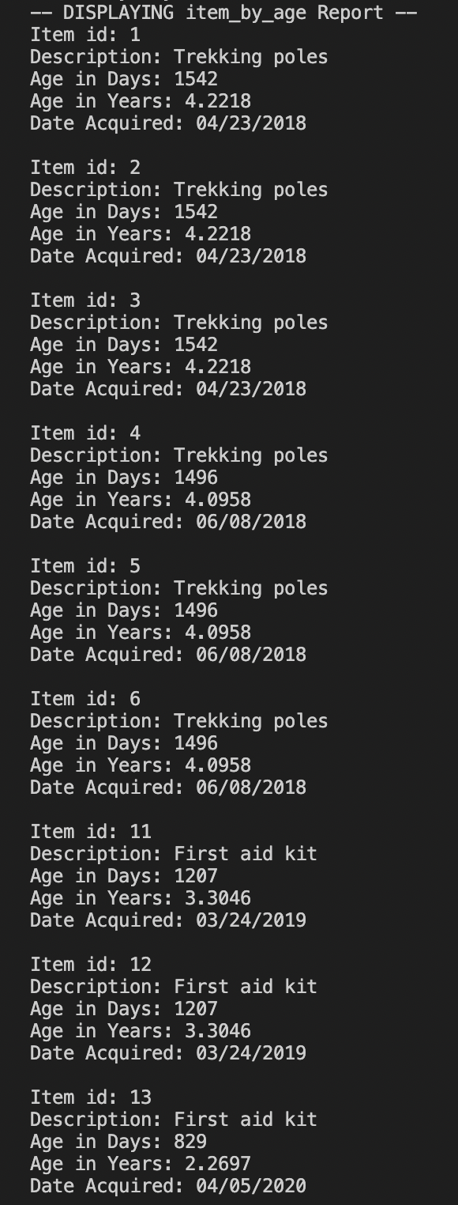

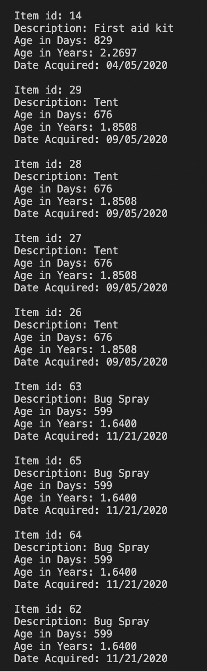

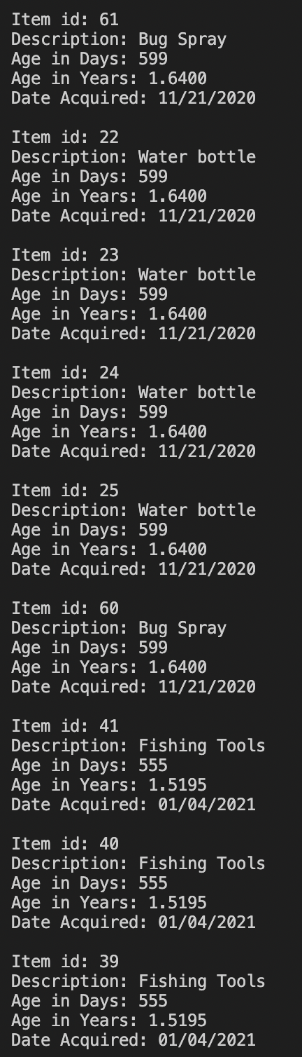

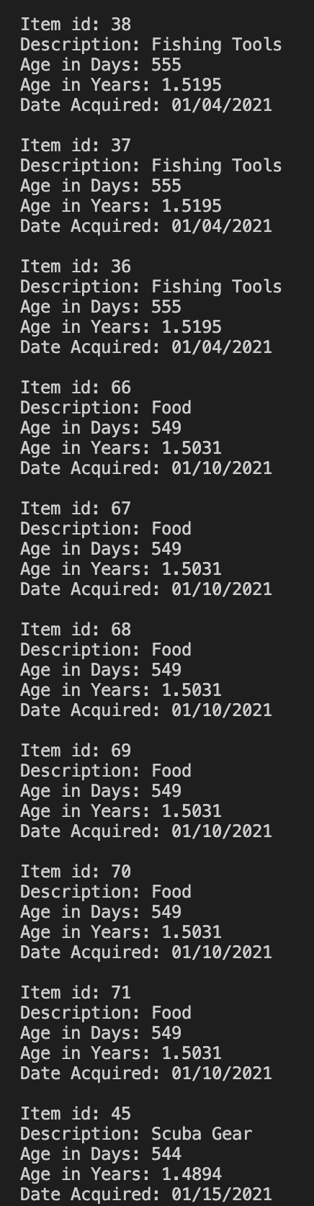

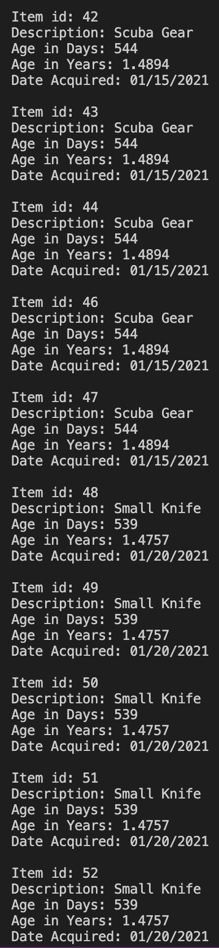

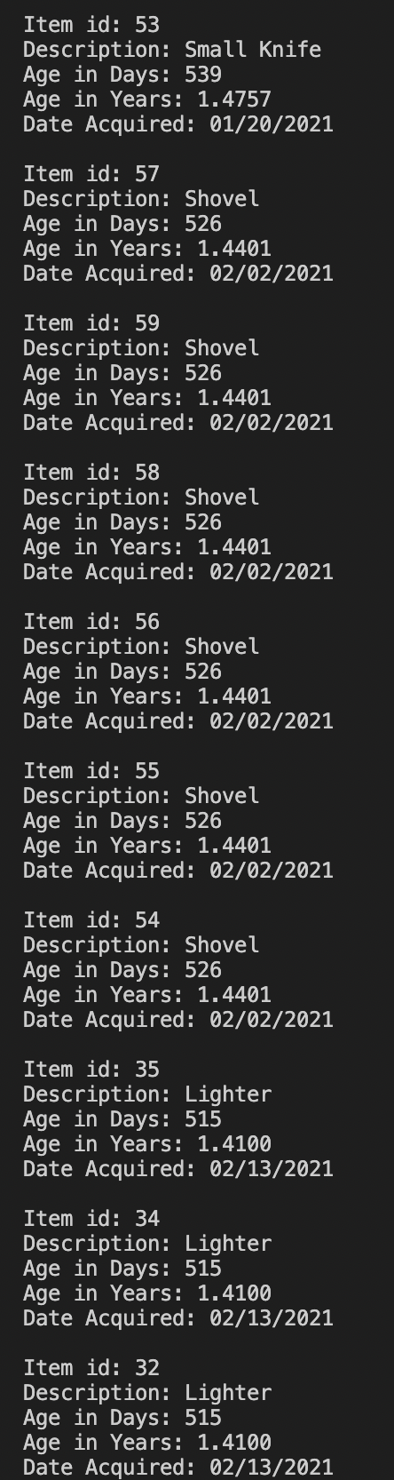

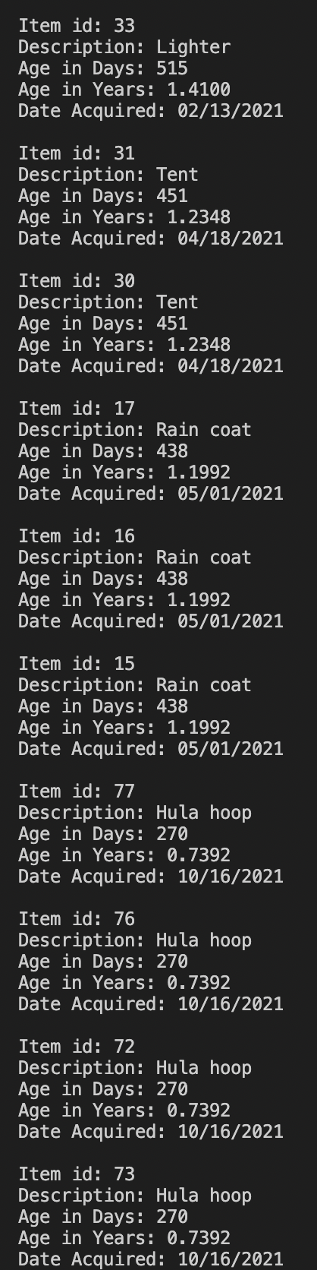

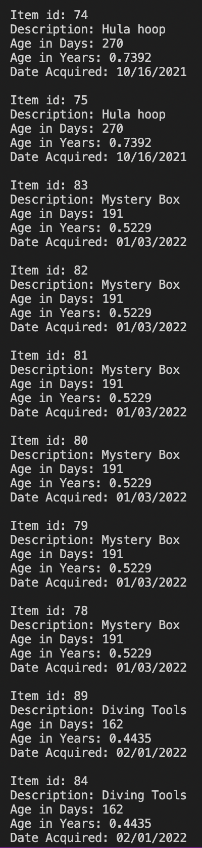

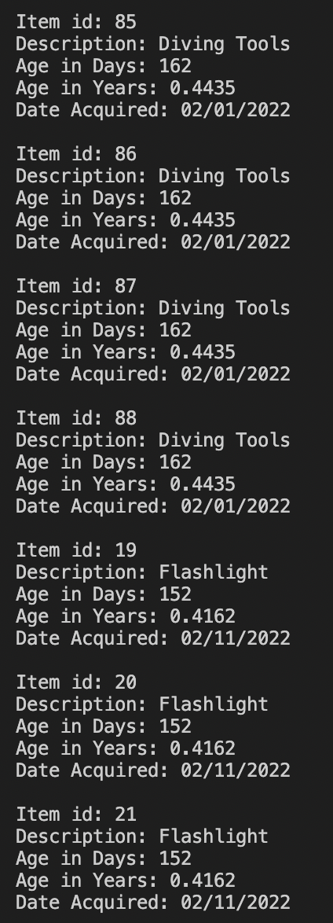

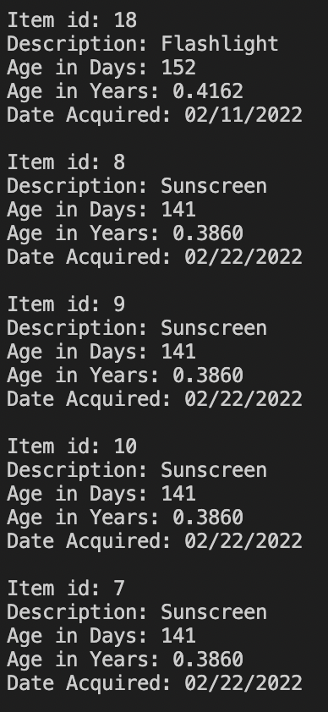

*Date Run: 07/17/2022*

### Report Description

This report can either be a fixed view or a procedure. These reports build on the last one by limiting the returned records to only the items with an age greater than or equal to the specified age. The age value can be hard coded into a select statement or view, or the procedure can be called with an int value to be used as the age in the command. Dimitrios needed a report to view items that were greater than 5 years old. While you could hard code 5 as the age or input 5 into the procedure and it would return the correct records, our data assumed most items were purchased new in recent years and no items are over 5 years old. If you run either report with a lower value such as an age of 3 or 4, it will return matching records.

#### 10-B.Item By Age Report Interactive

--items over X years old

SELECT I.item_id, IT.description,

DATEDIFF(CURDATE(), I.date_aquired) AS 'Age in Days',

DATEDIFF(CURDATE(), I.date_aquired)/365.25 AS 'Age in Years',

DATE_FORMAT(I.date_aquired,'%m/%d/%Y') AS 'Date Acquired'

FROM item AS I

JOIN item_type AS IT

ON i.item_type_id = IT.item_type_id

WHERE (DATEDIFF(CURDATE(), I.date_aquired)/365.25) >= 4

ORDER BY I.date_aquired;

--create procedure

CREATE PROCEDURE OldItems (IN age int)

BEGIN

SELECT I.item_id, IT.description,

DATEDIFF(CURDATE(), I.date_aquired) AS 'Age in Days',

DATEDIFF(CURDATE(), I.date_aquired)/365.25 AS 'Age in Years',

DATE_FORMAT(I.date_aquired,'%m/%d/%Y') AS 'Date Acquired'

FROM item AS I

JOIN item_type AS IT

ON i.item_type_id = IT.item_type_id

WHERE (DATEDIFF(CURDATE(), I.date_aquired)/365.25) >= age

ORDER BY I.date_aquired;

END

CALL OldItems(4)

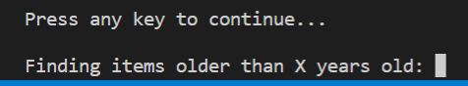

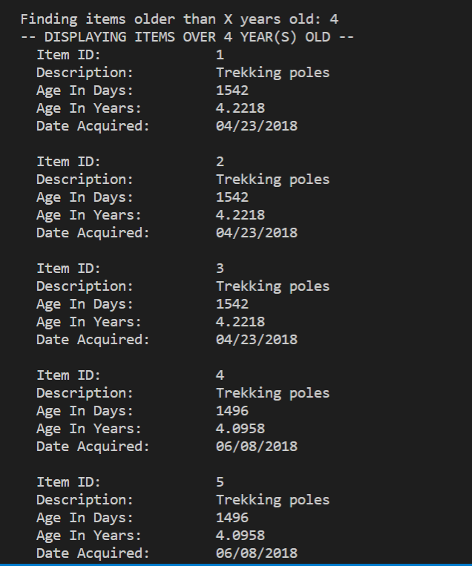

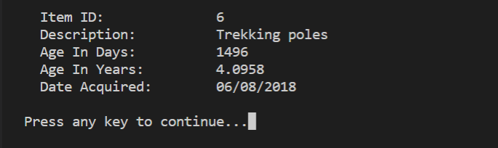

*Date Run: 07/17/2022*

**END**